St Jude’s Church of England Primary Academy

Calculation Policy
Reception – Year 6

Aims:

The mathematics teaching at St Jude’s Church of England Primary Academy is geared towards enabling each pupil to develop within their capabilities; not only the mathematics skills and understanding required for later life but also an enthusiasm for and fascination about mathematics itself.
We aim to increase pupil confidence in mathematics so that they are able to express themselves and their ideas using the language of mathematics with assurance.
Our aim is that the children see a clear link between mental strategies and written methods. They are encouraged to ask themselves, “Do they need a written method?” before attempting a question. For calculations that they cannot do in their heads they choose an appropriate written method which they can use accurately and with confidence. Time must be taken to build up to the most efficient method to ensure complete understanding at each stage.

The aim of this policy is to show clear progression and a systematic approach in written and mental strategies taught to children in Reception through to Year 6. Whilst each step is given as an expectation for the end of each year group, when the child is exceeding expectations and is ready to move onto the next step, teachers should be quick to introduce that next stage of learning.

Addition
Learning Stage | Visual | Written Methods  Counting & Mental Methods | National Curriculum end of year expectations
Reception | 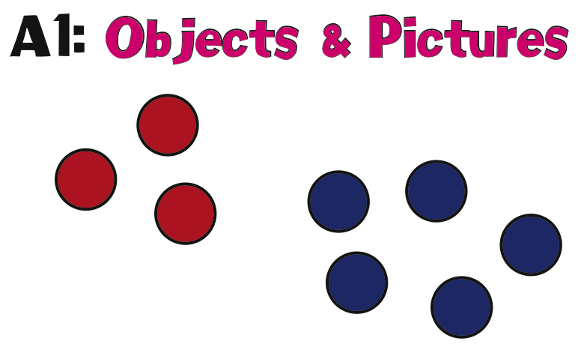 | Pupils should show written recordings when a number is one more or one less than a number.  Pupils see many visual representations of number and count singular groups. This leads to putting two groups together and calculating the total. | - ELG – Children count reliably with numbers from 1 to 20, place them in order and say which number is one more or one less than a given number. Using quantities they add and subtract two single digit numbers and count on or back to find the answer.  - Exceeding – Children estimate a number of objects and check quantities by counting up to 20.
Year 1 | 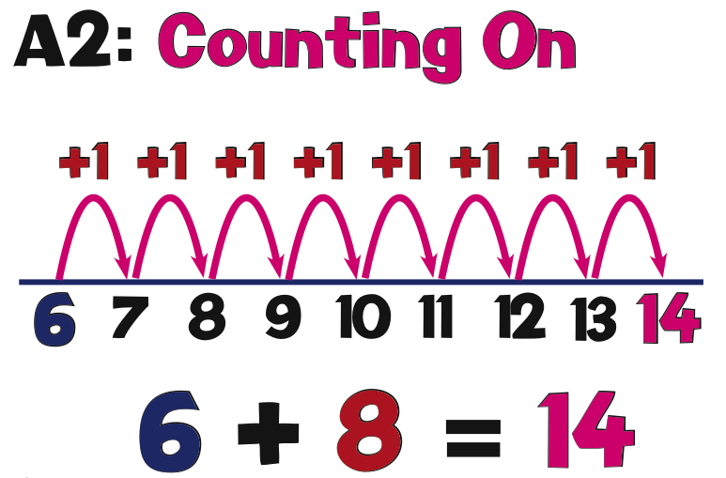  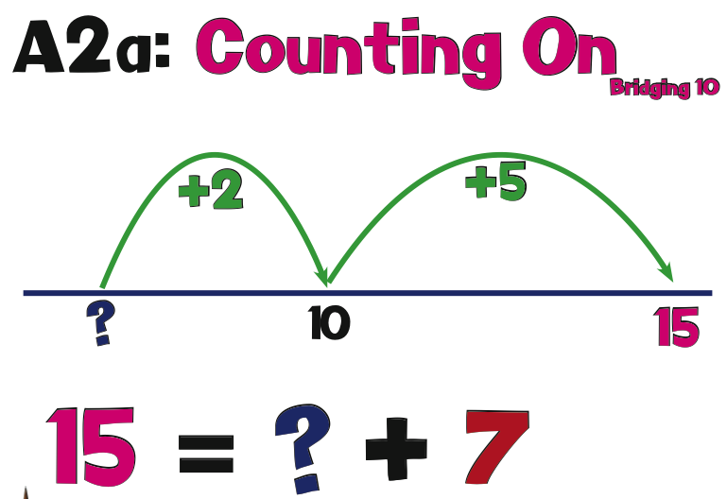 | Pupils begin to use number line representation and counting on from the number with most value.  Pupils to begin to use number line representation as a mental strategy for addition | - Read, write and interpret mathematical statements involving addition (+), subtraction (−) and equals (=) signs  - Represent and use number bonds and related subtraction facts within 20  - Add and subtract one-digit and two-digit numbers to 20, including 0  - Solve one-step problems that involve addition and subtraction, using concrete objects and pictorial representations, and missing number problems such as 7 = ? − 9
Year 2 | 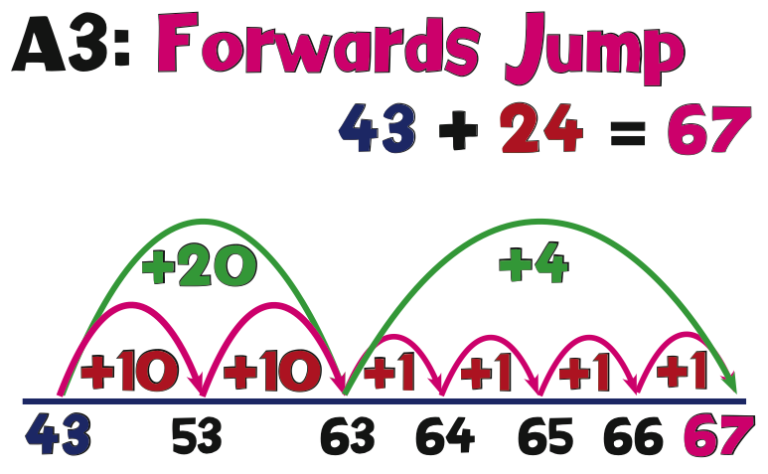  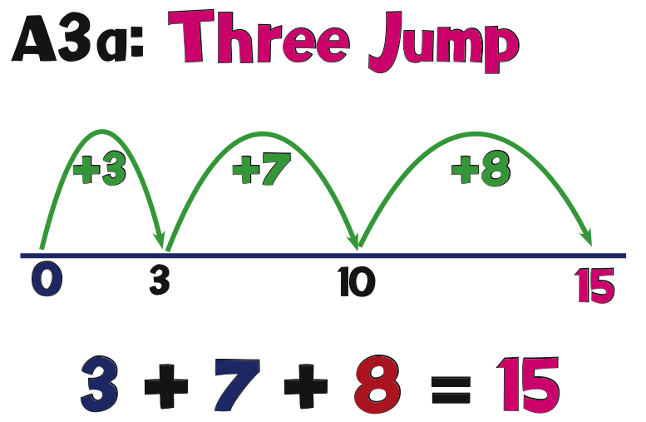  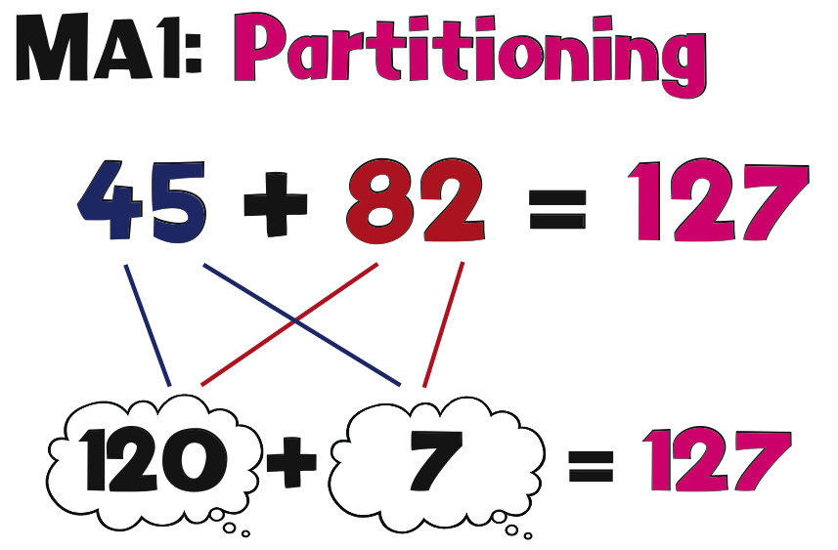  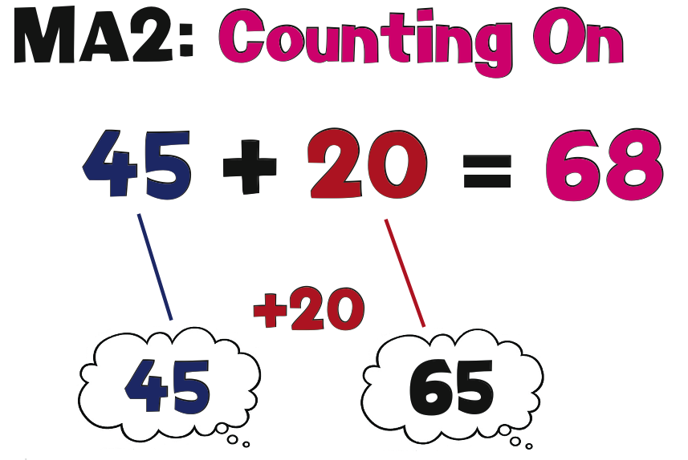 | Pupils are introduced to partitioning. They practice counting on a number line by adding the ‘tens’ and then the ‘units’.  Pupils begin to add together three single digit numbers using mental strategies. | - Solve problems with addition and subtraction:  - Using concrete objects and pictorial representations, including those involving numbers, quantities and measures  - Applying their increasing knowledge of mental and written methods  - Recall and use addition and subtraction facts to 20 fluently, and derive and use related facts up to 100  - Add and subtract numbers using concrete objects, pictorial representations, and mentally, including:  A two-digit number and 1s  A two-digit number and 10s  2 two-digit numbers  Adding 3 one-digit numbers  - Show that addition of 2 numbers can be done in any order (commutative) and subtraction of 1 number from another cannot  - Recognise and use the inverse relationship between addition and subtraction and use this to check calculations and solve missing number problems
Year 3 | 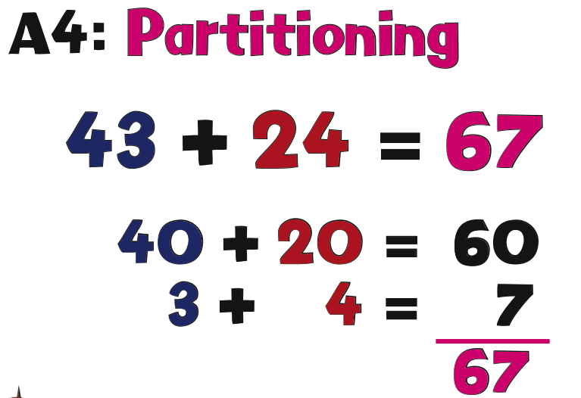  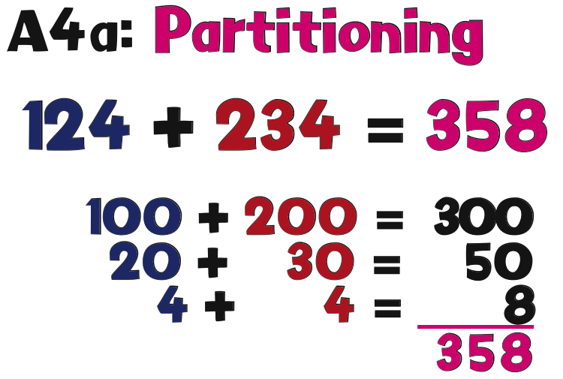  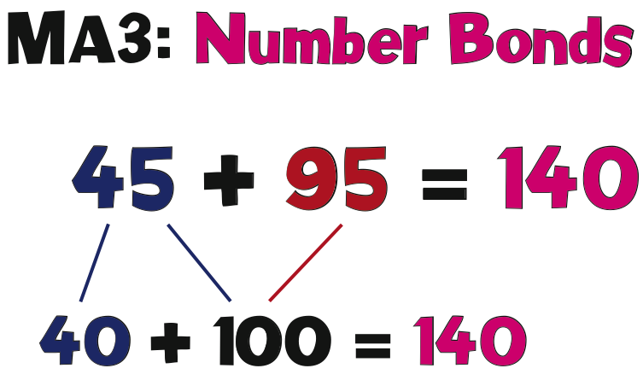 | Pupils are introduced to expanded column addition using up to three digit numbers. Pupils begin to manipulate place value column and add HTU. At this stage they jot the full value for each column. This leads to understanding of ‘exchanging/carrying’ the ten/hundred digit for column addition. | - Add and subtract numbers mentally, including:  - a three-digit number and 1s  - a three-digit number and 10s  - a three-digit number and 100s  - Add and subtract numbers with up to 3 digits, using formal written methods of columnar addition and subtraction  - Estimate the answer to a calculation and use inverse operations to check answers  - Solve problems, including missing number problems, using number facts, place value, and more complex addition and subtraction
Year 4 | 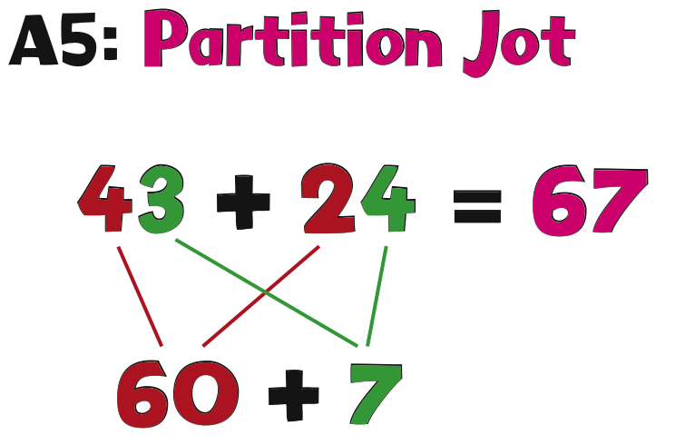  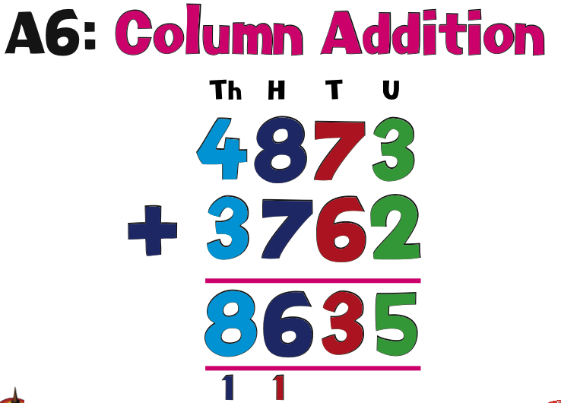  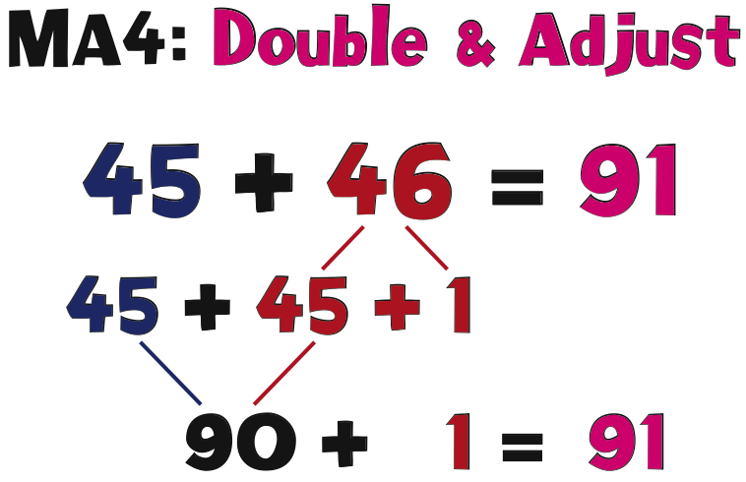  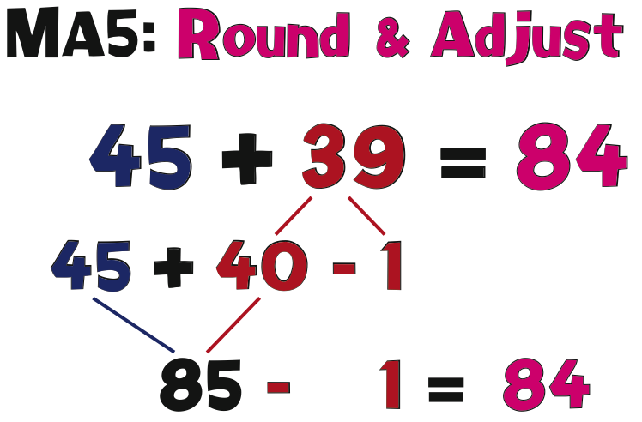 | Pupils are introduced to column addition using up to four digit numbers. Pupils understand partitioning and have a good understanding of place value to be able to use standard column addition. They understand the concept of exchanging/carrying when adding columns. | - Add and subtract numbers with up to 4 digits using  the formal written methods of columnar addition and subtraction where appropriate  - Estimate and use inverse operations to check answers to a calculation  - Solve addition and subtraction two- step problems in contexts, deciding which operations and methods to use and why
Year 5 | 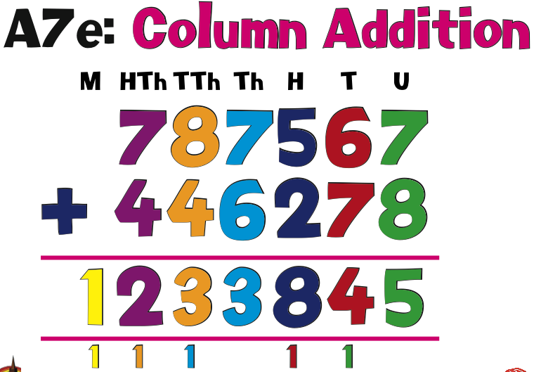 | Pupils understand partitioning and have a good understanding of place value to be able to use standard column addition for numbers greater than 999. Pupils are introduced to decimal numbers up to two decimal places. | - Add and subtract whole numbers with more than 4 digits, including using formal written methods (columnar addition and subtraction)  - Add and subtract numbers mentally with increasingly large numbers  - Use rounding to check answers to calculations and determine, in the context of a problem, levels of accuracy  - Solve addition and subtraction multi-step problems in contexts, deciding which operations and methods to use and why
Year 6 | 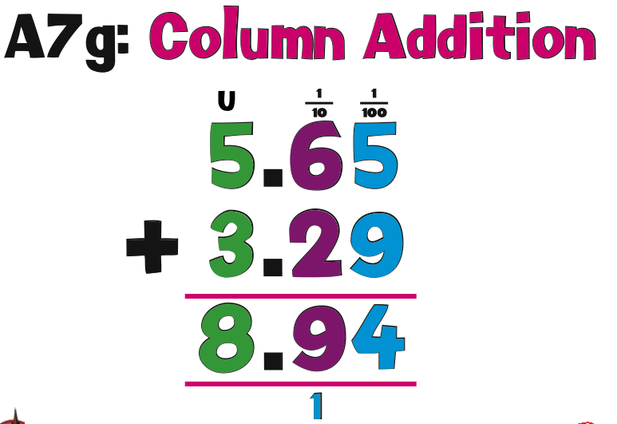 | Pupils have a secure understanding of column addition using numbers larger than four digits as well as decimals to two decimal places. | - Solve addition and subtraction multi-step problems in contexts, deciding which operations and methods to use and why  - Solve problems involving addition, subtraction,  - multiplication and division  - Use estimation to check answers to calculations and determine, in the context of a problem, an appropriate degree of accuracy

Subtraction
Learning Stage | Visual | Written Methods  Counting & Mental Methods | National Curriculum end of year expectations
Reception | 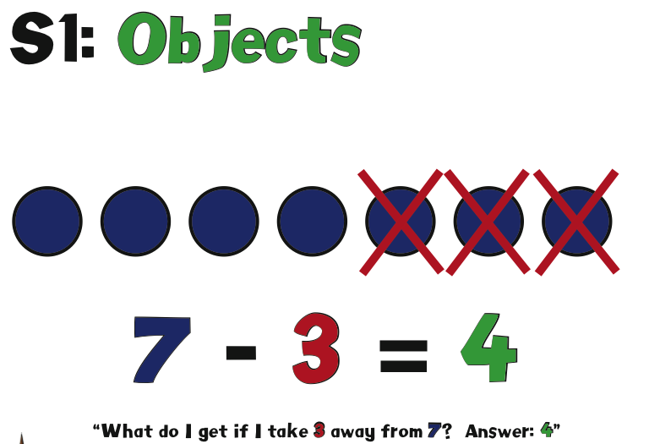 | Pupils take away an amount from a set of physical objects and count/record the remaining object.  Pupils take away an amount from a set of physical objects and count/record the remaining object. | - ELG – Children count reliably with numbers from 1 to 20, place them in order and say which number is one more or one less than a given number. Using quantities they add and subtract two single digit numbers and count on or back to find the answer.
Year 1 | 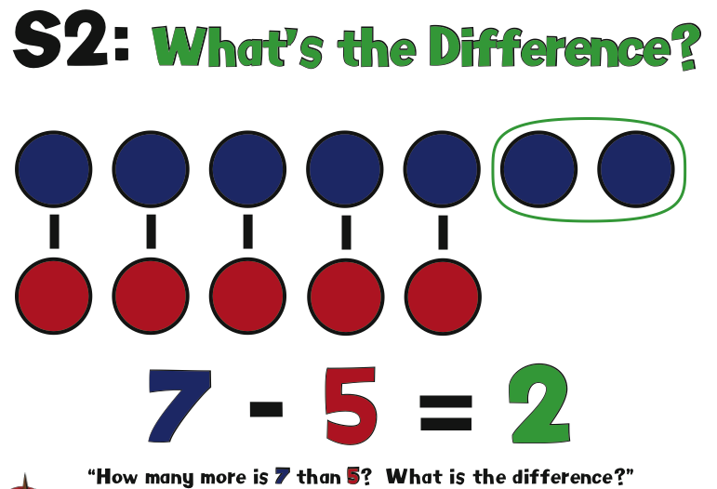  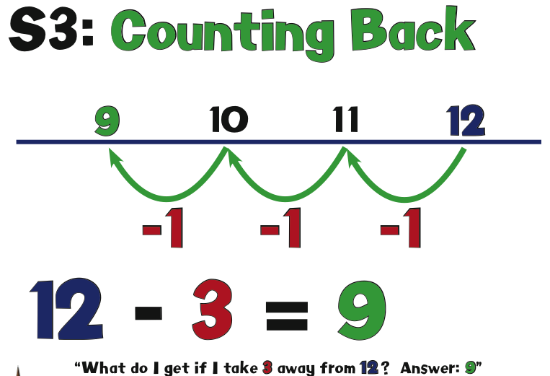 | As pupils knowledge of counting forwards and backwards (number bonds of 20) increases, they are encouraged to apply this when using the ‘counting back’ strategy. This is represented with resources such as number lines and number squares  Pupils are introduced to the concept of ‘difference’ with physical and visual prompts. This is with numbers no greater than 20 as the main focus is in the pupils ‘seeing’ and understanding concept. | - Read, write and interpret mathematical statements involving addition (+), subtraction (−) and equals (=) signs  - Represent and use number bonds and related subtraction facts within 20  - Add and subtract one-digit and two-digit numbers to 20, including 0  - Solve one-step problems that involve addition and subtraction, using concrete objects and pictorial representations, and missing number problems such as 7 = ? − 9
Year 2 | 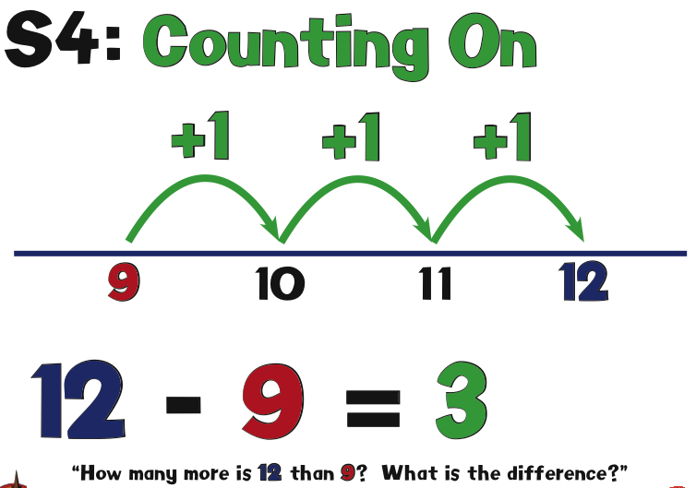  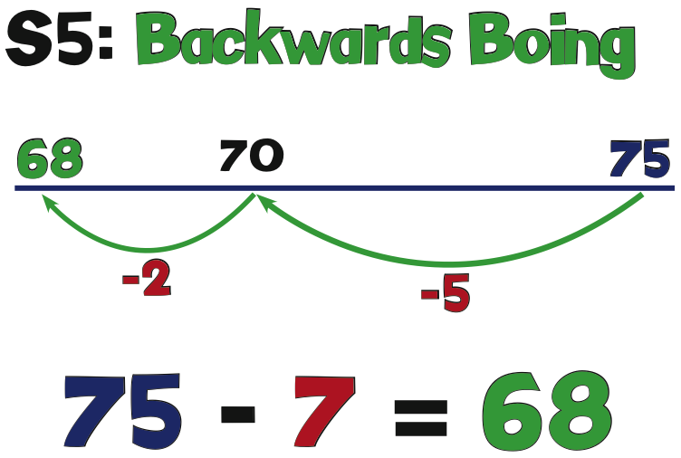  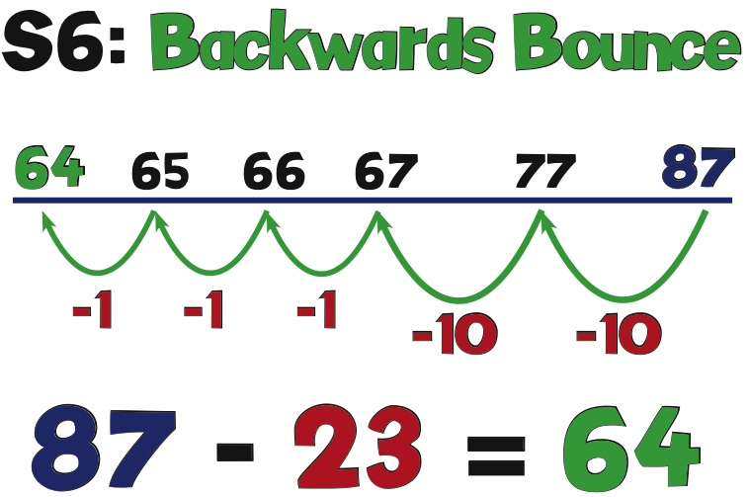  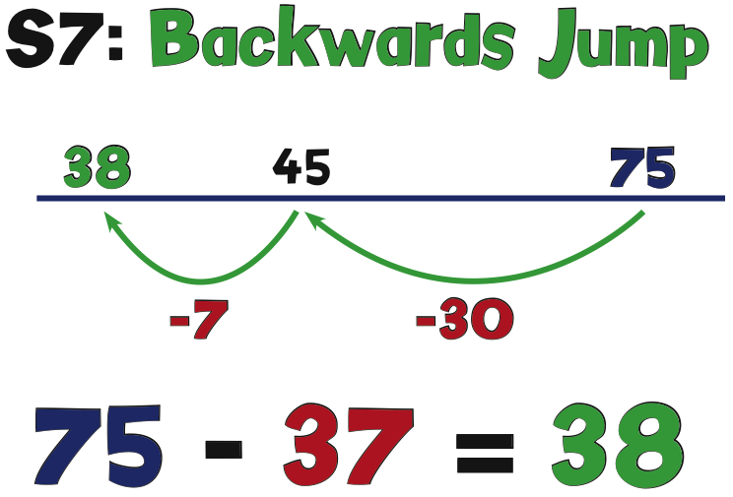  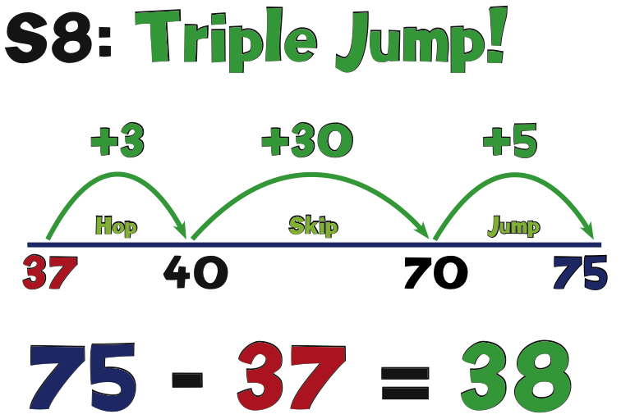  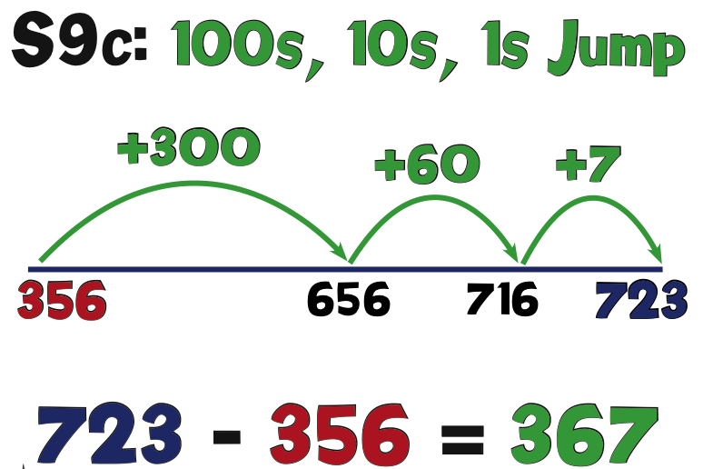 | Pupils begin to understand the importance of the ‘milestone’ number within the ‘tens’ and use this platform to help count on. They are encouraged to make links between jumping in ‘ones’ and then ‘tens’ with partitioning.  When pupils are confident with the concept of subtraction they are encouraged to use the ‘counting on’ strategy. This will give them confidence in subtracting a big number from another big number. | - Solve problems with addition and subtraction:  - Using concrete objects and pictorial representations, including those involving numbers, quantities and measures  - Applying their increasing knowledge of mental and written methods  - Recall and use addition and subtraction facts to 20 fluently, and derive and use related facts up to 100  - Add and subtract numbers using concrete objects, pictorial representations, and mentally, including:  - A two-digit number and 1s  - A two-digit number and 10s  - 2 two-digit numbers  - Adding 3 one-digit numbers  - Show that addition of 2 numbers can be done in any order (commutative) and subtraction of 1 number from another cannot  - Recognise and use the inverse relationship between addition and subtraction and use this to check calculations and solve missing number problems
Year 3 | 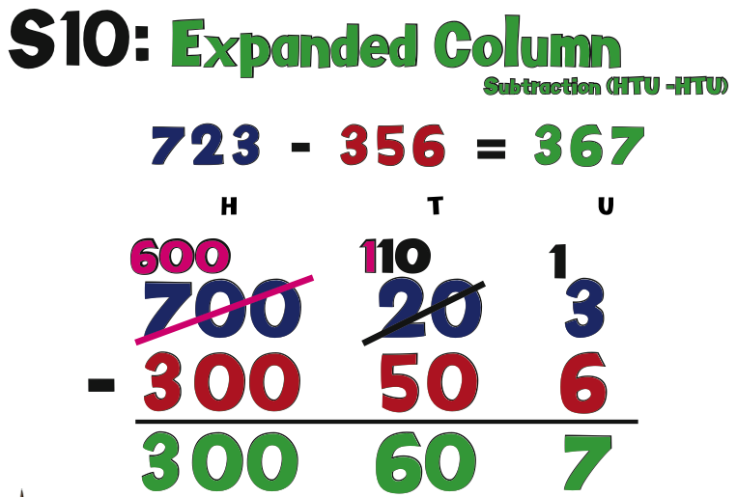  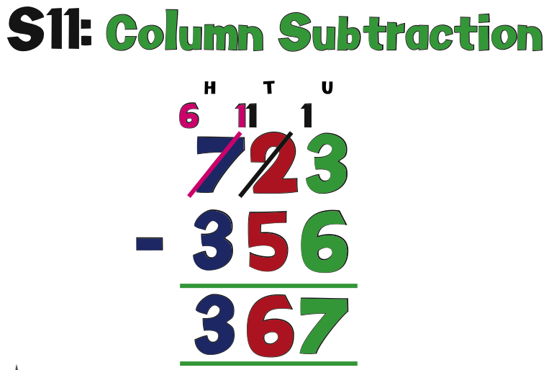 | With good understanding of partitioning and place value, pupils begin to use this as a strategy to subtract numbers greater than 100. They record their work in a way that represents ‘exchanging/borrowing’ 10’s, 100’s etc. | - Add and subtract numbers mentally, including:  - a three-digit number and 1s  - a three-digit number and 10s  - a three-digit number and 100s  - Add and subtract numbers with up to  3 digits, using formal written methods of columnar addition and subtraction  - Estimate the answer to a calculation and use inverse operations to check answers  - Solve problems, including missing number problems, using number facts, place value, and more complex addition and subtraction
Year 4 | 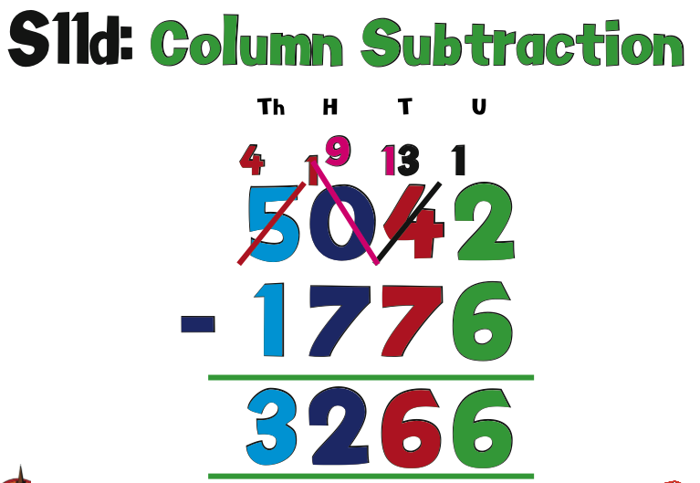 | Pupils are introduced to standard column subtraction as their knowledge of place value and partitioning allows them to fully understand this method | - Add and subtract numbers with up to 4 digits using the formal written methods of columnar addition and subtraction where appropriate  - Estimate and use inverse operations to check answers to a calculation  - Solve addition and subtraction two- step problems in contexts, deciding which operations and methods to use and why
Year 5 | 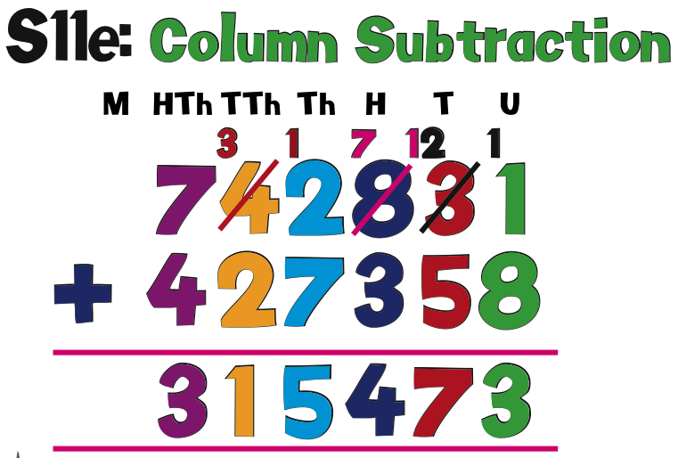 | Pupils continue to use standard column subtraction as their knowledge of place value and partitioning allows them to fully understand this method. Pupils are introduced to decimal numbers to two decimal places. | - Add and subtract whole numbers with more than 4 digits, including using formal written methods (columnar addition and subtraction)  - Add and subtract numbers mentally with increasingly large numbers  - Use rounding to check answers to calculations and determine, in the context of a problem, levels of accuracy  - Solve addition and subtraction multi-step problems in contexts, deciding which operations and methods to use and why
Year 6 | 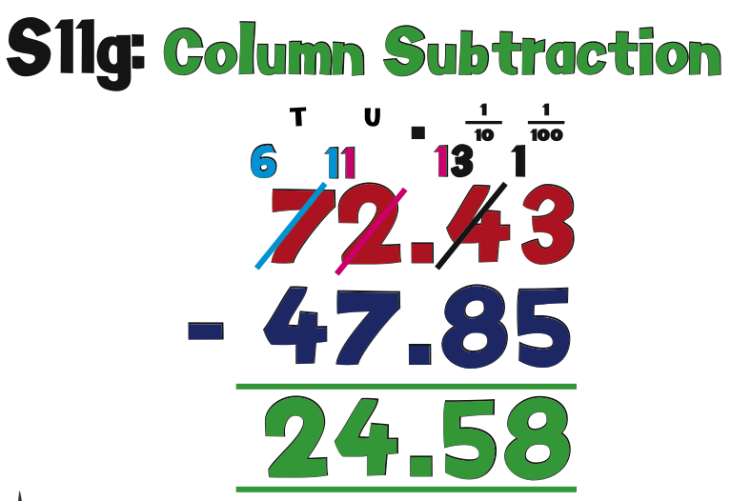 | Pupils are secure in using standard column subtraction as their knowledge of place value and partitioning allows them to fully understand this method | - Solve addition and subtraction multi-step problems in contexts, deciding which operations and methods to use and why  - Solve problems involving addition, subtraction, multiplication and division  - Use estimation to check answers to calculations and determine, in the context of a problem, an appropriate degree of accuracy

Multiplication
Learning Stage | Visual | Written Methods  Counting & Mental Methods | National Curriculum end of year expectations
Reception | 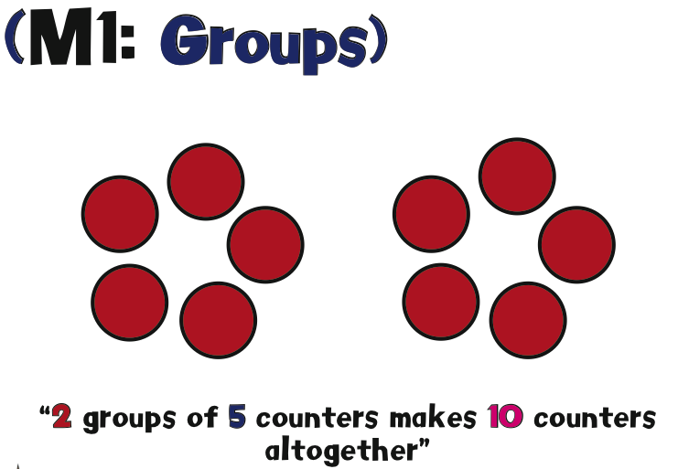  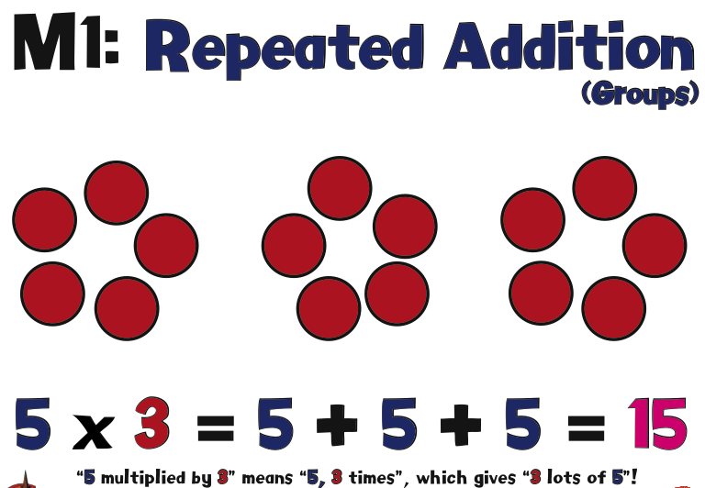 | Pupils begin to see multiplication as a number that is repeating itself. This is represented with physical objects and visuals (Groups) | - ELG - They can solve problems including doubling, halving and sharing  - Exceeding – They can solve practical problems that involve combining groups of 2, 5 or 10, or share into equal groups.
Year 1 | 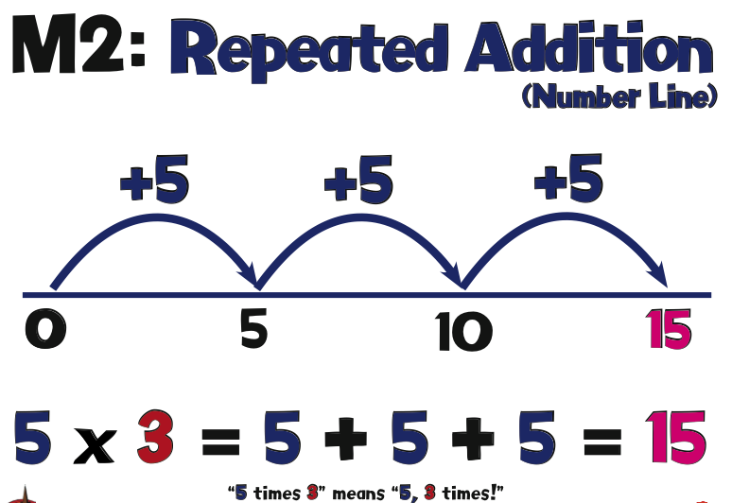  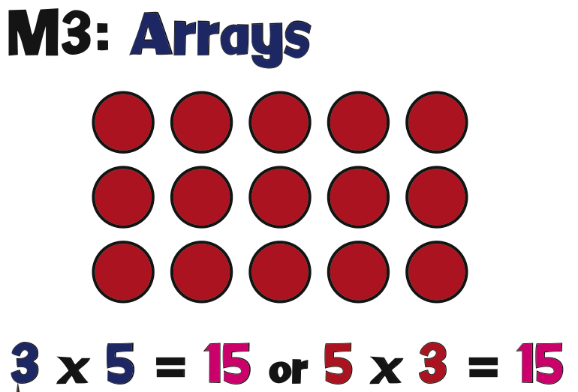 | Pupils are introduced to arrays in order to visualise the concept. As fluency in 2, 5 and 10 times table improves, pupils count along a number line in repeated amounts to a given number. This is immediately transferred on to the pupils fingers so they start to count with repeated addition and multiply with number sense. | - Solve one-step problems involving multiplication and division, by calculating the answer using concrete objects, pictorial representations and arrays with the support of the teacher.
Year 2 | 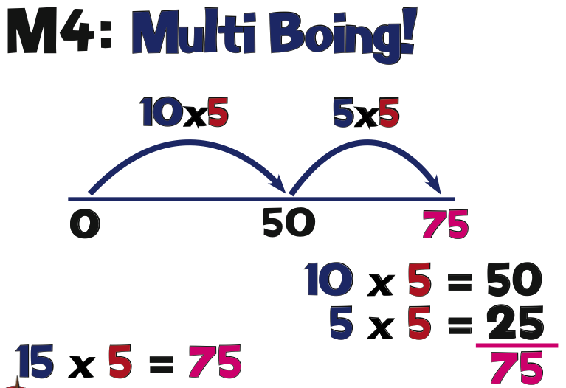 | Visual prompts of arrays are used so pupils can see given numbers multiplying. They are encouraged to see both multiplication problems within the array e.g. 3 x 5 = 5 x 3 | - Recall and use multiplication and division facts for the 2, 5 and 10 multiplication tables, including recognising odd and even numbers  - Calculate mathematical statements for multiplication and division within the multiplication tables and write them using the multiplication (×), division (÷) and equals (=) signs  - Show that multiplication of two numbers can be done in any order (commutative) and division of one number by another cannot  - Solve problems involving multiplication and division, using materials, arrays, repeated addition, mental methods, and multiplication and division facts, including problems in contexts.
Year 3 | 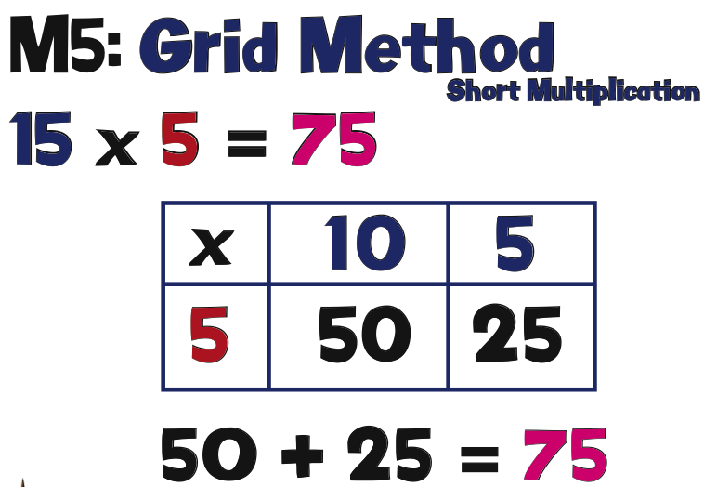  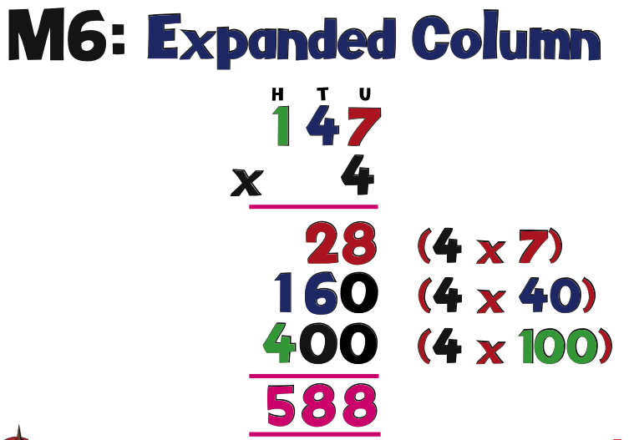 | As pupils become more fluent with the concepts of place value and partitioning they are taught the grid method. The numbers remain relatively straightforward (2,5,10) so pupils become fluent with the strategy first. | - Recall and use multiplication and division facts for the 3, 4 and 8 multiplication tables  - Write and calculate mathematical statements for multiplication and division using the multiplication tables that they know, including for two-digit numbers times one-digit numbers, using mental and progressing to formal written methods
Year 4 | 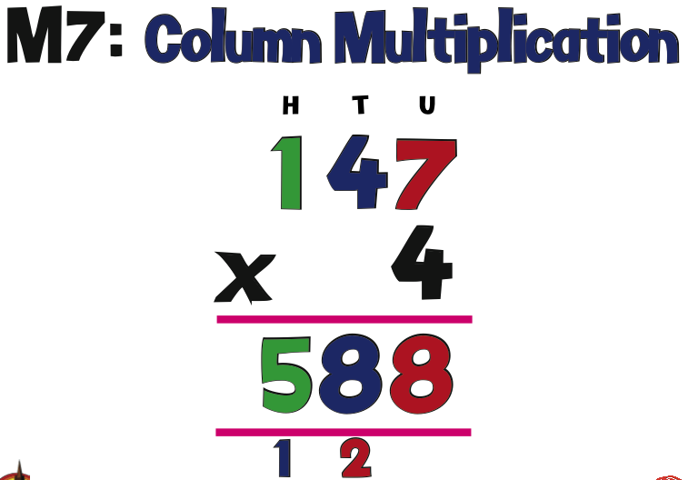  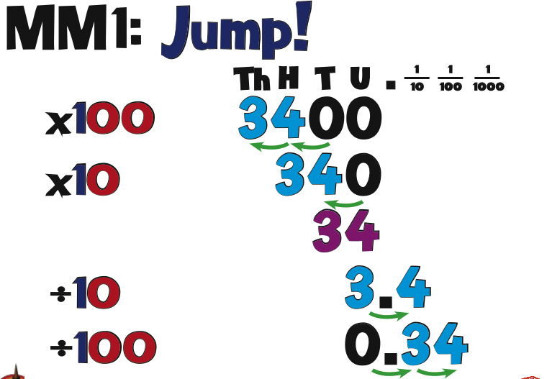 | Pupils are ‘lead’ into column multiplication through the expanded column method so they can make the links with partitioning, place value and how the ‘carries’ exchange. | - Recall multiplication and division facts for multiplication tables up to 12 × 12  - Use place value, known and derived facts to multiply and divide mentally, including: multiplying by 0 and 1; dividing by 1; multiplying together three numbers  - Recognise and use factor pairs and commutativity in mental calculations  - Multiply two-digit and three-digit numbers by a one-digit number using formal written layout
Year 5 | 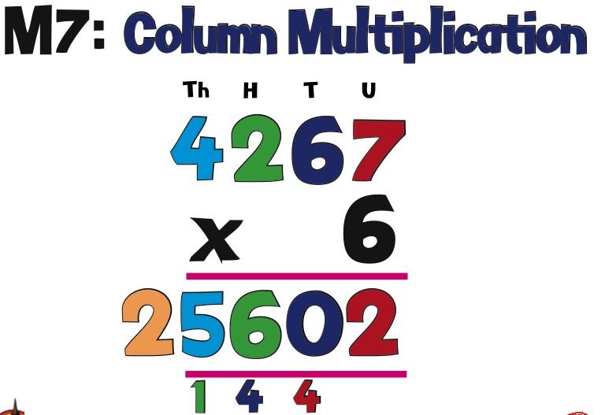 | Pupils are lead onto standard column multiplication to improve efficiency.  With in depth number sense and knowledge of partitioning pupils can multiply one, two digit numbers by another. They understand ‘0’ is the placeholder in the second step on the strategy because we multiply the ‘one/unit’ by the digit in the tens column. Therefore the product is ten times bigger. | - Identify multiples and factors, including finding all factor pairs of a number, and common factors of two numbers  - Know and use the vocabulary of prime numbers, prime factors and composite (non-prime) numbers  - Establish whether a number up to 100 is prime and recall prime numbers up to 19  - Multiply numbers up to 4 digits by a one- or two-digit number using a formal written method, including long multiplication for two-digit numbers  - Multiply and divide numbers mentally drawing upon known facts  - Multiply and divide whole numbers and those involving decimals by 10, 100 and 1000
Year 6 | 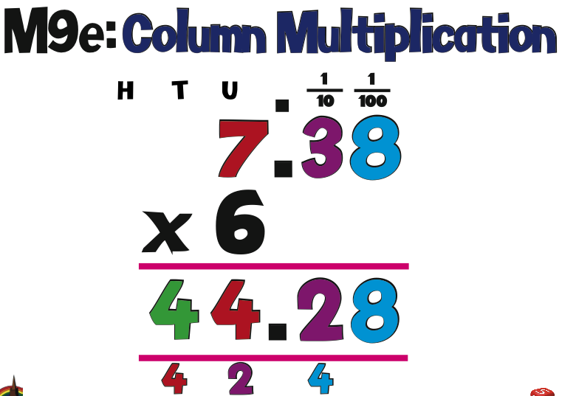  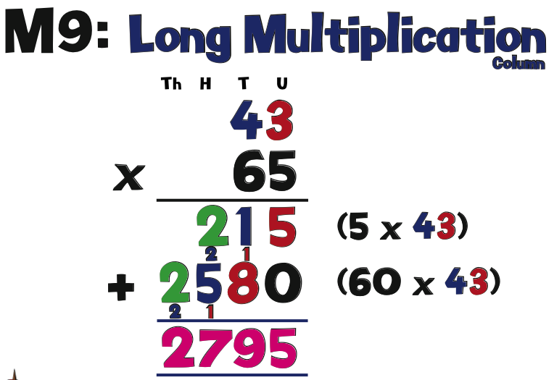 | Pupils have a secure knowledge of standard and long multiplication working with numbers up-to four digits long. Pupils are introduced to multiplying units and tenths by units as well as multiplying simple fractions (not mixed number fractions) | - Multiply multi-digit numbers up to 4 digits by a two-digit whole number using the formal written method of long multiplication  - Perform mental calculations, including with mixed operations and large numbers  - Identify common factors, common multiples and prime numbers

Division
Learning Stage | Visual | Written Methods  Counting & Mental Methods | National Curriculum end of year expectations
Reception | 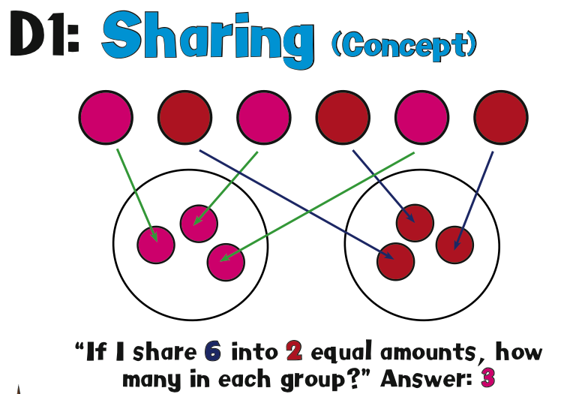 | Pupils begin to see division through the concept of sharing. The main focus is for children to see that amounts can be shared into equal groups. | - ELG - They can solve problems including doubling, halving and sharing  - Exceeding – They can solve practical problems that involve combining groups of 2, 5 or 10, or share into equal groups.
Year 1 | 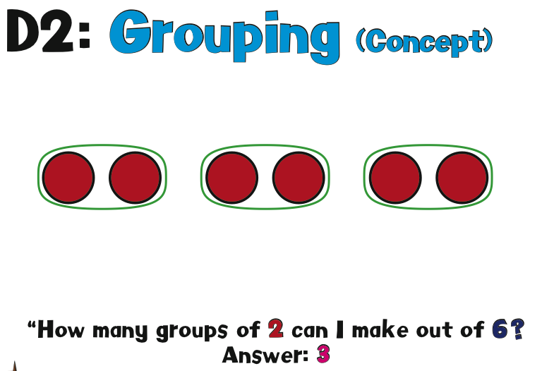  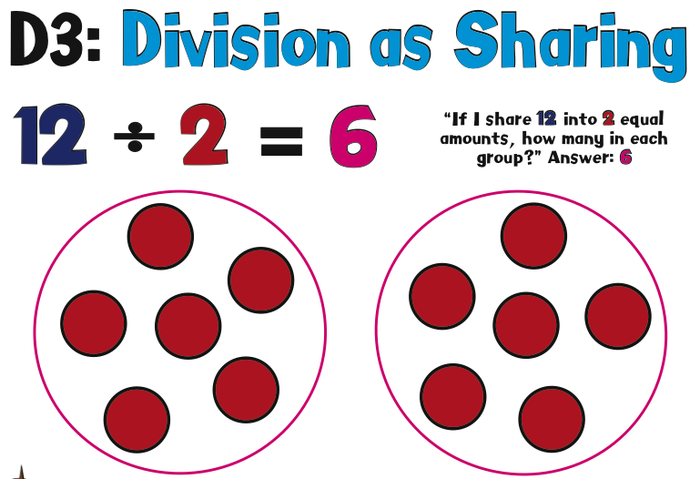  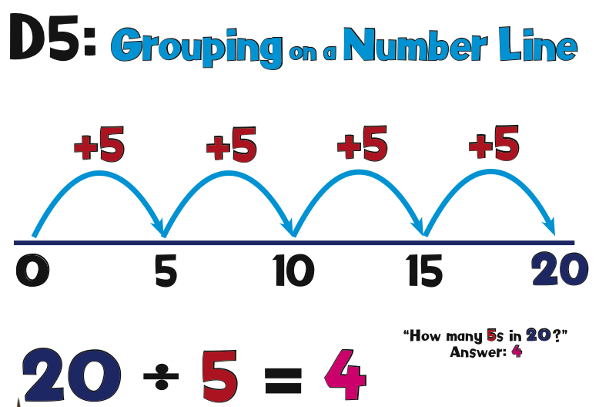 | As fluency in 2,5 & 10 times tables improves, pupils count along a number line in repeated amounts to a given number.  From written methods the strategy is then transferred on the pupils fingers so they start to count with repeated addition and multiplication. Pupils begin to see the importance on this and start to relate this to the concept of inverse. | - Solve one-step problems involving multiplication and division, by calculating the answer using concrete objects, pictorial representations and arrays with the support of the teacher.
Year 2 | 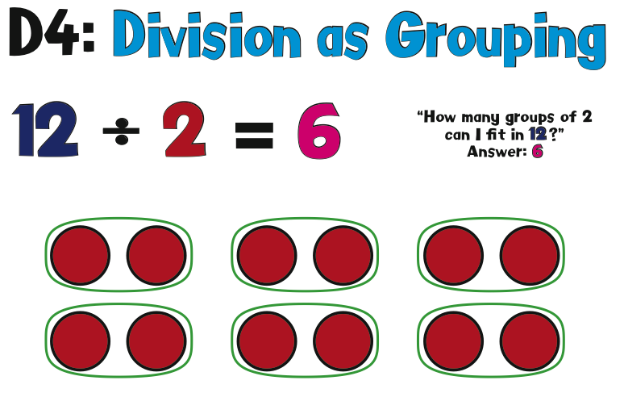  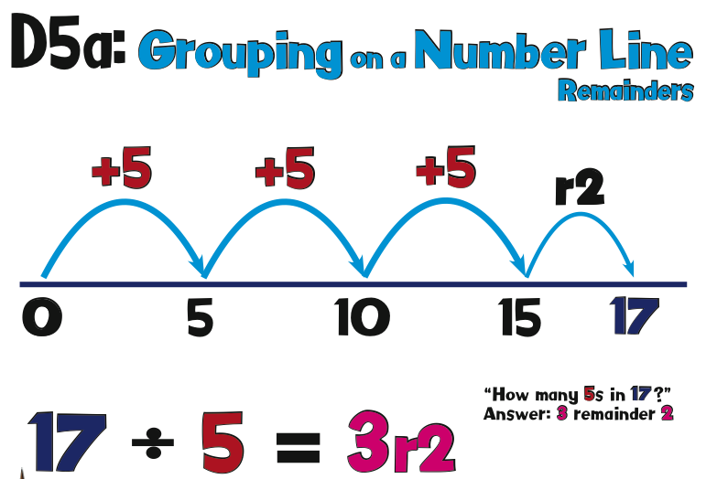  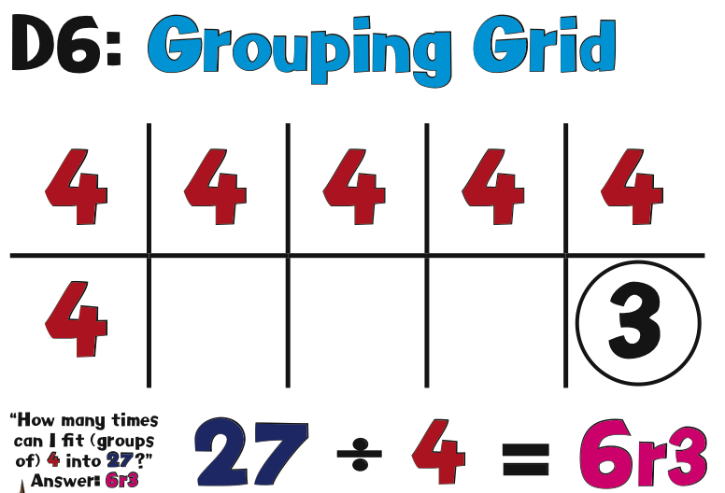 | Visual prompts of arrays are used so pupils can see given amounts being divided. They are encouraged to see different division facts within an array e.g. 12 / 2 = 6 or 12 / 6 = 2.  The connection between x and / is emphasised throughout the whole teaching process. | - Recall and use multiplication and division facts for the 2, 5 and 10 multiplication tables, including recognising odd and even numbers  - Calculate mathematical statements for multiplication and division within the multiplication tables and write them using the multiplication (×), division (÷) and equals (=) signs  - Show that multiplication of two numbers can be done in any order (commutative) and division of one number by another cannot  - Solve problems involving multiplication and division, using materials, arrays, repeated addition, mental methods, and multiplication and division facts, including problems in contexts.
Year 3 | 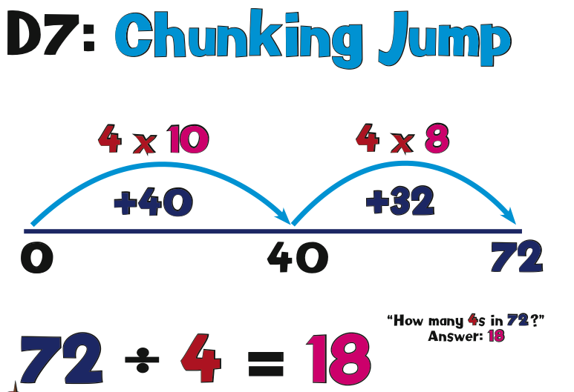  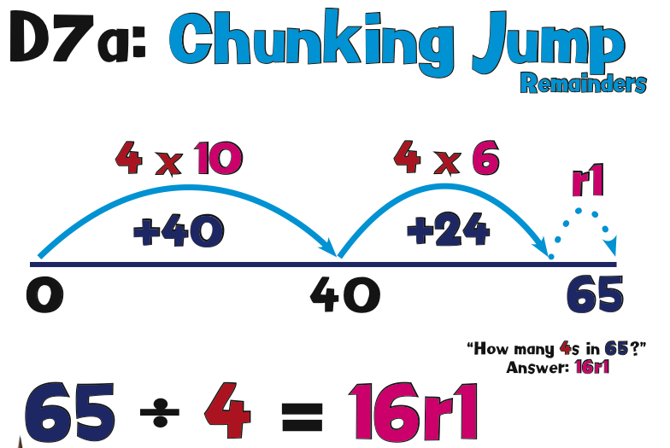  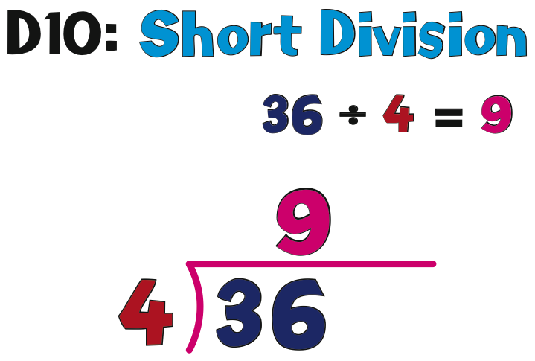 | Pupils understand that / means ‘how many __ go into __? Pupils are progressing towards division including units by tens & units e.g. 36 / 4.  They use their knowledge of times table facts to calculate division problems mentally. This demonstrates the pupils full understanding of the division as a concept. | - Recall and use multiplication and division facts for the 3, 4 and 8 multiplication tables  - Write and calculate mathematical statements for multiplication and division using the multiplication tables that they know, including for two-digit numbers times one-digit numbers, using mental and progressing to formal written methods
Year 4 | 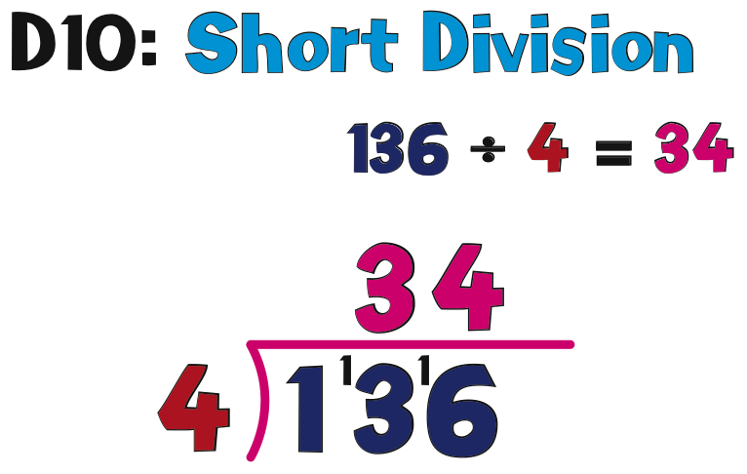  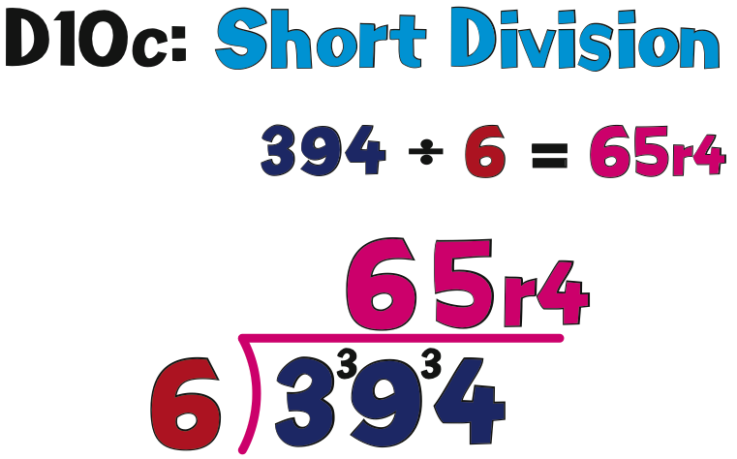 | As pupils knowledge of place value and partitioning grows they are introduced to short division. Pupils use their knowledge of times table facts to help them calculate an answer for a division problem with a secure understanding of how the inverse is helping them. | - Recall multiplication and division facts for multiplication tables up to 12 × 12  - Use place value, known and derived facts to multiply and divide mentally, including: multiplying by 0 and 1; dividing by 1; multiplying together three numbers  - Recognise and use factor pairs and commutativity in mental calculations
Year 5 | 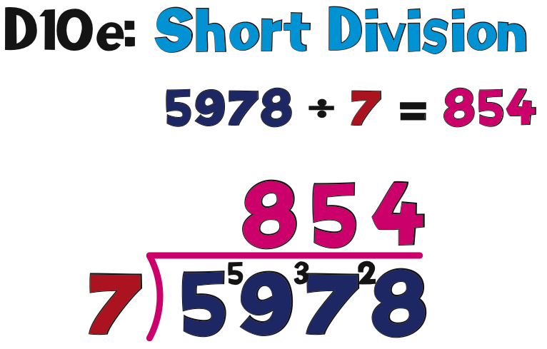  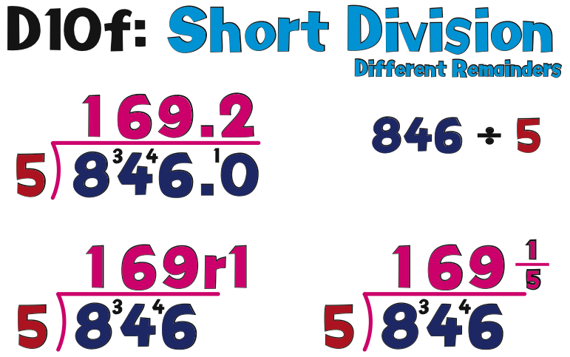 | Pupils develop their fluency with short division and can use it to calculate multi-digit numbers by a divisor of 1 digit including numbers that may have remainders. | - Identify multiples and factors, including finding all factor pairs of a number, and common factors of two numbers  - Know and use the vocabulary of prime numbers, prime factors and composite (non-prime) numbers  - Establish whether a number up to 100 is prime and recall prime numbers up to 19  - Multiply and divide numbers mentally drawing upon known facts  - Divide numbers up to 4 digits by a one-digit number using the formal written method of short division and interpret remainders appropriately for the context  - Multiply and divide whole numbers and those involving decimals by 10, 100 and 1000
Year 6 | 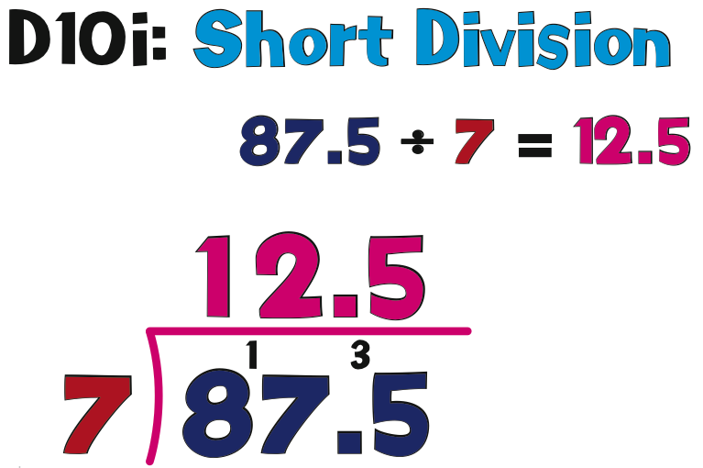  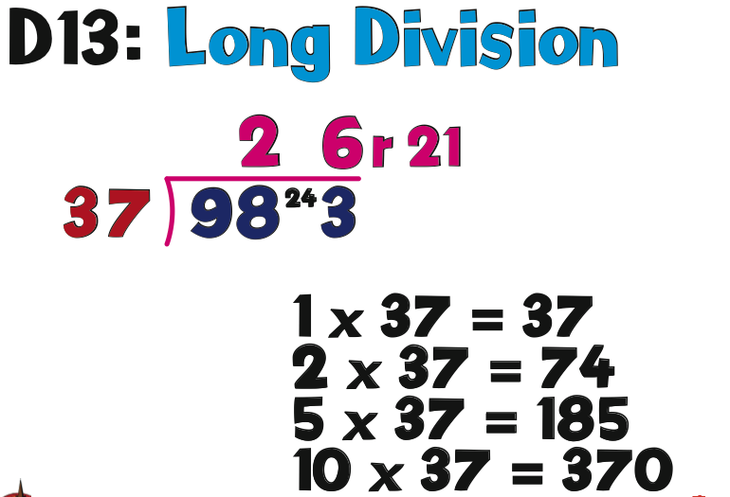 | Pupils are then introduced to long division in order to divide multi-digit numbers by a divisor of 2 digits | - Divide numbers up to 4 digits by a two-digit whole number using the formal written method of long division, and interpret remainders as whole number remainders, fractions, or by rounding, as appropriate for the context  - Divide numbers up to 4 digits by a two-digit number using the formal written method of short division where appropriate, interpreting remainders according to the context  - Perform mental calculations, including with mixed operations and large numbers  - Identify common factors, common multiples and prime numbers

Pupils are encouraged to use and apply each method in various real life scenarios such as ‘money problems’ and ‘measure problems’. By the end of KS2 pupils are confident with decimals and have an in depth knowledge of the place value system and how it can be manipulated in order to help us add, subtract, multiply and divide efficiently, effectively and accurately.

